Colour and strength of dental zirconia
As we use zirconia more and more in the dental industry, the range of available zirconias appears to grow daily. We started with the basic, high strength but rather opaque zirconia, with technicians trying hard to create more translucency. The manufacturers responded by offering us a much improved ‘HT’ version, with a lot more translucency. And now we have even greater translucency with the latest zirconia which has a similar translucency to porcelain but considerably more strength. I wonder what’s next!
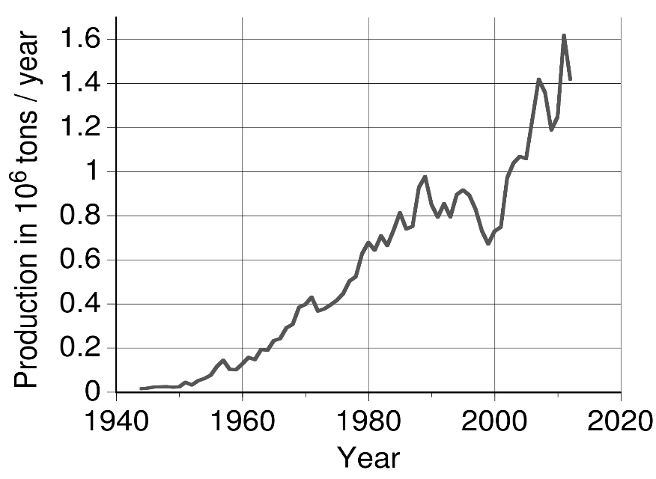
With every different supplier there are now any number of claims regarding the strength. Are they true? Are they independently tested? Are all the tests standardised so we can compare different zirconias from different manufacturers? And now we have greater ranges of pre-coloured zirconia coming onto the market and even multilayer discs! But how does colour affect the strength, if at all?
How do we judge the quality of the zirconia we are buying? I think most of us check the strength and the price, and then the translucency of the results. Whilst results and the price we can see for ourselves, strength is taken on trust as we cannot verify it.
There are a number of factors affecting the strength of these zirconias, but the first to look at is the method of production, then we can check any colour issues.
There are about 70 manufacturers of dental zirconia worldwide, with 20 of those being in China, and there are three methods of producing the nano zirconia powder needed to manufacture the discs we use. (‘nano’ just means the particles are less than one thousandth of a mm). The methods are co-precipitation, hydrolysis and hydrothermal.
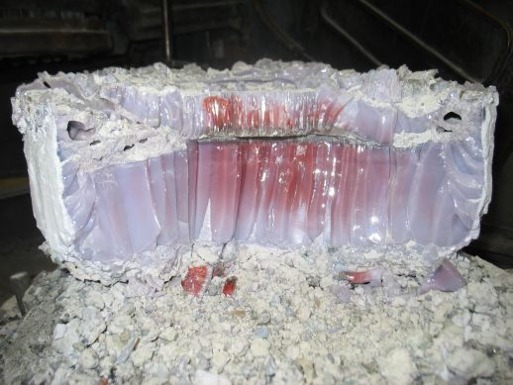
Partially stabilised zirconia
The first, co-precipitation, is the cheapest method and low quality discs are made from powder produced in this way. Next comes hydrolysis which is where, at less than 100 deg C and at under normal pressure, the powder is washed, calcined and ball milled. Finally, powder produced hydrothermally is kept over 140 deg C and under high pressure. This produces the most homogenous nano zirconia particles, but is also the most expensive process.
Should we check on the manufacture of the zirconia we use? Probably…
Clearly, homogeneity will affect the strength, but it is difficult to quantify.
Next up, let’s look briefly at the testing results:
We are given the MPa value of the zirconia we buy ie. the flexural strength, but what we may not realise is that in tests there is always a big variation. So is the claimed strength that is provided the best result or an average, or just a hope? In results I have seen on one zirconia said to be over 700 MPa, the variation was from 445 MPA to 681 MPa, with the real average being 580 MPa, so a rather optimistic claim in this case. A variation of around 20% seems common, so strengths claimed by suppliers may not always reflect the whole picture. It seems therefore, it may not be wise to choose one zirconia over another only because it’s stated strength is apparently higher. So how could we choose?
First let’s take a look at what difference, if any, adding colour can make to the average strength of the zirconia we use.
Colour is achieved by adding Iron oxide, Erbium oxide and Manganese oxide to the mix. If these oxide particles are not homogenously dispersed in the zirconia matrix, the strength of the zirconia will be greatly reduced. There are three ways to achieve a coloured zirconia:
- By adding the colour pigments at the powder producing stage
- By adding colour to the finished powder at the disc producing stage
- By adding coloured stains after milling the discs and before sintering
The strength of the zirconia coloured using method 3 is the highest, however, it is time consuming and difficult to achieve consistently accurate results. Some colouring liquids are also acid based and are harmful to the sintering furnace.
Method 2 gives the worst results, with a decrease in strength of between 20 and 40%, so should be avoided.
Method 1 is possibly the best option overall, with the decrease in strength only 5 to 15% and consistent colour across the disc. The sintering furnace is also preserved.
So you have been offered a ‘fantastic’ price for ‘high strength’ coloured zirconia…could it be the powder is made using the cheapest method of co-precipitation and the block manufacturer is adding colour pigments themselves to keep the price low? Do they have comprehensive research and development facilities with the capability to test accurately?
As with everything, you get what you pay for, and zirconia is no different. Unfortunately, with zirconia we may only discover we have used a lower quality product a few years down the line when we find we have more failures than expected. Check out your supplier!
Here at Bristol Cadcam, we choose our zirconia based on actual test results, a thorough check on the disc manufacturer and their chosen source of powder and the production methods used, and of course, on the results achieved at the bench.

Tim Brothers, Director, Bristol Cadcam Co Ltd., Bristol Crown Company Ltd

